Advanced Algebra Name: ____________________

Chapter 1.7 - 2.8 Test Period: ________
Section | 1.7 | 2.8 | Problem Solving | 2.4-retest
Score

For problems 1 – 4, solve the absolute value equation.

1. 1. ___________________________

2. 2. ___________________________

3. 3. ___________________________

4. 4. ___________________________

For problem 5, select the correct answer.
5. Which of the following is a solution of ? 5. __________

a. -30

b. -10

c. 0

d. 10
For problems 6 – 9, solve the absolute value inequality. Then graph your answer on the number line.

6. 6. ___________________________

7. 7. ___________________________

8. 5 8. ___________________________

9. 9. ___________________________

For problem 10, select the correct answer.

10. Which equation is represented by the graph shown? 10. __________

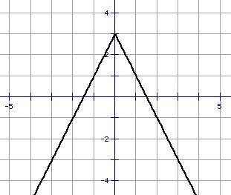
a.

b.

c.

d.

For problems 11 – 14, graph the absolute value equation.

11. 11. vertex: __________
axis of symmetry: __________
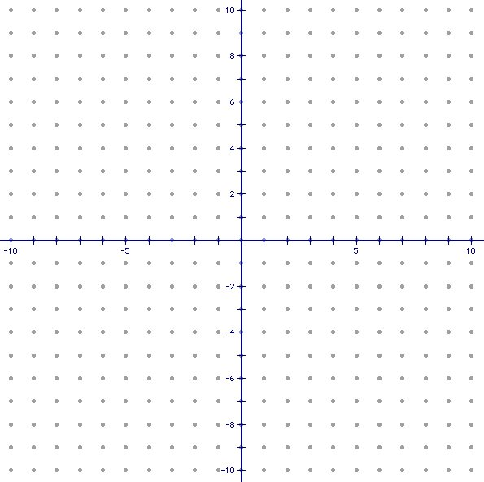

12. 12. vertex: __________
axis of symmetry: __________

13. 13. vertex: __________
axis of symmetry: __________

14. 14. vertex: __________
axis of symmetry: __________

For problem 15 – 17, use the following information to answer the problem.

15. The length of a standard basketball court can vary from 84 feet to 94 feet, inclusive.
Write an absolute value inequality that describes the possible lengths
of a standard basketball court.

15. ___________________________

16. How many solutions are there to ? Explain why.

16. ___________________________
Explain: _____________________
_____________________________
_____________________________
_____________________________

17. The roof line of an A-frame home follows the path given by .

a. Find the vertex of the absolute value equation.

17a. ___________________________

b. What does the y-value of the vertex tell us about the home?

17b. ___________________________
___________________________
___________________________

For problems 18 – 21, write the equation of the line in point-slope form AND slope-intercept form.
18. Through the point (12, 6) with slope .
18. Point-slope: _____________

Slope-intercept: _________

19. Through the points (8, 12) and (2, -8).

19. Point-slope: _____________

Slope-intercept: _________

20. The line passes through (2, 6) and is parallel to y = 2x – 3.

20. Point-slope: _____________

Slope-intercept: _________

21. The line passes through (-10, -1) and is perpendicular to y = -x + 10.

21. Point-slope: _____________

Slope-intercept: _________

